
Microsoft® PowerPoint® 2000

Product Enhancements Guide

Published: October 1998

Table of Contents
Introduction 1
Overview of New Features 2
Web-Enabled Information Sharing 2
Real-Time Collaboration 3
Ease of Use 4
Feature Details 6
HTML Document Creation and Publishing 6
Real-time Collaboration 9
Personal Productivity 13
End-User Assistance and Training 15
Multilingual User Support 16
Conclusion 17

Microsoft PowerPoint 2000
Product Enhancements Guide

Published: October 1998
For the latest information, please see http://www.microsoft.com/office/

Introduction
Microsoft® PowerPoint® 2000 was created to be the easiest tool to create presentations and to present to audiences in face-to-face meetings, in meetings conducted in remote locations or on the Web.

Traditionally, presenters have had to travel to reach audiences in different parts of the country or the world. With today’s new technologies, this is no longer necessary. Presenters can now easily and inexpensively collaborate on presentations and present to remote audiences without leaving their offices.

PowerPoint 2000 combines new ease-of-use features that speed users through presentation development, the ability to create Web-based presentations and the ability to easily present to remote audiences. PowerPoint allows presenters to use the familiar presentation tools they already know in PowerPoint to present and collaborate over the Intranet. The key focus for PowerPoint 2000 covers four main areas:

- Enable Web-centered information sharing. As more and more organizations move to doing business in a Web-based environment, PowerPoint 2000 enables them to create and share presentations on the Web. Users can now work entirely in HTML file format or in the PowerPoint 2000 binary file format, which is compatible with PowerPoint 97.
- Facilitate real-time collaboration. PowerPoint 2000 integrates two Microsoft technologies - the NetShow™ server and NetMeeting™ conferencing software - to enable users to collaborate over the network in real time.
- Take ease of use to the next level. New features such as Tri-Pane View, Tables, AutoFit Text and AutoFormat As You Type enable users to get more done with noticeably less effort.
- Provide support for international users. PowerPoint 2000 provides a single code base for all worldwide users, making it as easy to use multiple language versions of PowerPoint as it is to use one. For example, proofing tools and other language-dependent functions work as well when the user is creating documents in more than one language as they do in a monolingual document.

Overview of New Features
The new features in PowerPoint 2000 are a direct result of extensive research and customer feedback. The PowerPoint team has learned that customers using PowerPoint are driven by deadlines and use the product approximately six hours a week — less time than they use many of the other applications in the Office suite. When the time comes for them to create a presentation, they need to be able to quickly and easily learn the product and produce the final presentation.

PowerPoint 2000 includes new and enhanced features to make it easier for beginners and infrequent users to be productive very quickly. From creating HTML presentations to sharing files in real time over an intranet to creating multilingual presentations, PowerPoint 2000 provides the tools that all levels of users need to easily create great-looking presentations.

Web-Enabled Information Sharing
By taking advantage of open Internet standards, PowerPoint 2000 allows customers to successfully share information and collaborate in a Web-based environment. As more organizations develop intranets where users publish, share, collaborate and manage their presentations in a Web work space, PowerPoint 2000 will assist in enabling this new level of integration with the Web. Customers can easily create and share rich Web presentations with the same tools they’ve been using to create PowerPoint presentations, and the information is universally viewable in a browser.

HTML Document Creation and Publishing

 | Feature | Description
New | HTML as Native File Format | PowerPoint 2000 can save to and read from HTML files with high fidelity. HTML is elevated to the same level as the binary file format (.ppt).
New | Features Preserved in HTML | Users can select HTML as the default file format while still taking advantage of key PowerPoint features and functionality.
Improved | Save to the Web | This allows users to save a PowerPoint presentation in HTML format directly to a Web server. This ability enables all users to contribute to an intranet without having to rely on a “webmaster” to post files for them.
New | Web Graphics Optimization | Microsoft Internet Explorer 5.0 will display and scale vector graphics natively, providing better display and smaller files for HTML PowerPoint presentations.
New | Dual HTML Output Format | Users can save presentations in a dual v3-v4 mode, which allows them to optimize for Internet Explorer 4.0 while preserving compatibility with v3 browsers. Presentations can also be published in v3-only format.

 | Feature | Description
New | HTML Output Options | Users can choose from several built-in formatting options when creating PowerPoint HTML presentations, including format, resolution, frame style, color, speaker’s notes, outline, audio and scaling of slides and graphics.
New | Fit to Window | Slides automatically resize to fit the display resolution and window, so users no longer have to manually adjust their slides or screen resolution.
Improved | Navigation Bar | PowerPoint presentations saved in HTML include a navigation bar in a frame for easy navigation.
Improved | Notes Frame | Notes pages are automatically created in a separate frame for easy viewing.
Improved | Design Templates | Themes have been created and coordinated between some of the Office applications and the FrontPage® Web site creation and management tool to make it easy to create consistent-looking Web pages. PowerPoint 2000 includes Design Templates consistent with the Themes.
New | Present in Browser | PowerPoint HTML provides a button that launches the presentation in full screen. Presentations can be delivered using Internet Explorer version 4.0 or higher instead of a viewer.

Real-Time Collaboration
PowerPoint 2000 integrates two Microsoft technologies, NetShow and NetMeeting, to enable users to collaborate over the network in real time.

 | Feature |  | Description
New |  | Presentation Broadcast |  | Using Presentation Broadcast, users can deliver a presentation over an intranet, displaying the presentation slides in HTML along with the narration as streaming audio and video (video requires a NetShow server). Audience members require only an Internet Explorer 4.0 or higher browser to view the presentation.
New |  | Broadcast Schedule |  | Using the Outlook™ messaging and collaboration client, users can also schedule online broadcasts, set up reminders and click a button to join the broadcast.
New |  | Event Web Page |  | Using this page, others can tune in to watch the broadcast either during or after, or to get information before the broadcast starts.

 | Feature |  | Description
New |  | Presentations on Demand |  | Broadcasts are archived on a Web server and are available for playback at any time.
New |  | Online Meeting |  | Integration with Microsoft NetMeeting lets users start a conference and share any Office document with others for collaborative editing. Using Outlook, users can also schedule online meetings, set up reminders and click a button to join the meeting.

Ease of Use
Improvements and advancements in PowerPoint 2000 have been made in direct response to customers’ productivity needs. New tools and wizards have been introduced to help users more easily create presentations and to make common tasks simpler and more automated. Built-in intelligence has been extended to make it easy for users to work with presentations in HTML format for delivery over the Web.

Personal Productivity

 | Feature |  | Description
New |  | AutoFit Text |  | Text is automatically resized to fit into a placeholder so it doesn’t “fall off” the slide.
New |  | Tri-Pane View |  | Combines Slide, Outline and Notes view into one. This makes it easy to perform many actions, including adding new slides, editing text, entering notes while creating a presentation and navigation while editing.
New |  | Tables |  | PowerPoint 2000 supports creation of tables without use of Word or Microsoft Excel in place. These tables behave like those in Word, are composed of OfficeArt shapes to make them easy to edit, and are tied to text styles and themes. Tables round-trip to and from PowerPoint 2000.
New |  | Graphical Bullets |  | PowerPoint 2000 supports the use of graphics in place of bullets. Several samples are included, but any image can be used.
New |  | AutoNumbered Bullets |  | One of the most requested features from customers, AutoNumbered Bullets provide numbered bullets that automatically adjust their order in a logical sequence. These bullets recognize user intent when entering a number and format themselves as a numbered list.
 | Feature |  | Description
New |  | AutoFormat as You Type |  | Besides numbered bullets, PowerPoint also recognizes ordinals, fractions, em-dashes and en-dashes, rich text AutoCorrect entries and smart quotes followed by a number.
Improved |  | Flexible Handouts |  | This provides users with more output options for audience handouts.
New |  | Multiple Monitor Support |  | This allows a slideshow to be dragged to a secondary monitor. The Windows® 98 operating system or Windows NT® operating system version 5.0 is required.
New |  | Laptop Integration |  | Users can disable the Windows screensaver or the laptop’s low-power screen mode to avoid interruptions during a presentation.
Improved |  | Slide-Show Usability |  | Users can automatically hide the pointer and slide-show icon after a period of inactivity during a normal full-screen slide show. Minor mouse jiggles don’t cause the pointer to appear.
Improved |  | Voice Narration |  | Playback of narration is now synchronized with the original presentation, including all slide transitions and build animations. New functionality also allows slide-by-slide re-recording.
New |  | Animated GIFs |  | Animated GIFs can be inserted and displayed in a slide show and in the browser.
Improved |  | Additional AutoShapes |  | Over 50 new AutoShapes are included, including shapes for network diagrams, Web diagrams, conceptual diagram banners and office layouts.

End-User Assistance and Training

 | Feature |  | Description
New |  | Presentation Assistant |  | Using the Office Assistant, the Presentation Assistant consolidates several features and adds some new ones to help users create great presentations. This is not a feature found on a menu, but rather an integrated approach to assisting users through efforts to create, publish and deliver presentations. It incorporates StyleChecker and AutoClipArt.
New |  | PowerPoint Introduction |  | To help new and infrequent users be effective in PowerPoint, this self-paced introduction explains essential PowerPoint concepts.
New |  | Projector Wizard |  | Users can automatically set and restore correct screen resolution for a target projection system.
Improved |  | Animations User Interface |  | A more intuitive user interface provided for setting animations and grouping objects for concurrent animation.

Multilingual User Support
PowerPoint 2000 uses the same code base for all worldwide versions. Users can easily switch user interface languages as well as edit in different languages.

 | Feature |  | Description
New |  | Multilingual AutoCorrect |  | PowerPoint 2000 now supports multiple AutoCorrect Lists, one for each language.
Improved |  | Support for Far East Users |  | Additional Far East date formats, improved word-breaking and support for Far East HTML tags.
Improved |  | Language AutoDetect |  | PowerPoint 2000 determines language based on keyboard settings and applies the correct proofing tools.

Feature Details

HTML Document Creation and Publishing
PowerPoint 2000 offers a new Web-productivity work style that integrates core productivity tools with the Web to streamline the process of sharing information and working with others. As intranets become the repositories for company-critical information, users look to Web servers to provide some of the same — or better — tools and functionality of regular file servers. PowerPoint enables intranets to be used as a two-way Web, where users can publish, share, collaborate and manage documents all in one place. Users of PowerPoint 2000 can publish presentations directly to the Web as easily as they save to their hard drive. This enables users to create and share their organization’s most important asset — information.

HTML as Native File Format
To enable this new level of integration with the Web, PowerPoint 2000 has elevated HTML to be at the same level as its proprietary file format. This means that users can use HTML as their default file format and still use all the presentation features that they’re used to with the PowerPoint *.ppt format. The most important benefit of this greatly enhanced integration with the Web is that rich PowerPoint content is universally viewable by anyone with a browser.

The HTML file format can be read, re-edited and resaved without any loss of data. The content and formatting information is stored in HTML and additional round-tripping data is stored in the Extensible Markup Language (XML). This file format is viewable in Internet Explorer 4.0 or later.

All text, graphics, animations, voice narrations, sounds and movies are supported when viewed in the browser. Voice narrations are automatically saved in the NetShow Advanced Streaming Format (ASF) and streamed when viewed to avoid long initial download time.

Features Preserved in HTML
In preparing PowerPoint documents for the Web, HTML serves as the base technology, Cascading Style Sheets (CSS) as the mechanism for specifying formatting for the file and Extensible Markup Language as the way of storing data in the document that cannot be viewed in a browser. These technologies allow users to utilize HTML as the default file format while still taking advantage of key PowerPoint features and functionality.

Save to the Web
With PowerPoint 2000, publishing HTML documents to a Web server is as simple as saving a file to a hard drive. Opening, browsing and saving files on Web servers is done within the same file Open/Save dialog box that is used for regular files. And users can preview published documents in a Web browser right from PowerPoint. The File menu and Print Preview button have been expanded to support Web Page Preview, which enables users to see the final result just the way others will view it in their browsers.

Graphics Optimization
PowerPoint 2000 is being built to support emerging Internet standards, including Vector Markup Language (VML), which is a proposal for vector graphics submitted by the World Wide Web Consortium (W3C). Microsoft and other companies including Visio Corp., Autodesk Inc., Macromedia Inc. and Hewlett-Packard Co. have jointly submitted this proposal to the W3C to make editing, sharing and displaying vector graphics on the Web much easier and faster. In PowerPoint 2000, Office Art objects are created using VML so other applications supporting VML can edit, reshape and resize an Office Art object (after cutting and pasting it into another application). Another reason for saving Office Art objects in VML is VML-enabled browsers can download and render the images more quickly. Microsoft anticipates Microsoft Internet Explorer 5.0 and other browsers will support the rendering of vector graphics in the future. Currently there is no native support in browsers for displaying vector graphics objects because an HTML standard doesn’t exist. Instead, applications today save all vector graphics objects as raster images to be viewable in the browser, thus causing a major file size increase and longer download time.

Dual HTML Output Format
When users publish a PowerPoint 2000 presentation in HTML, they can do so in three different formats. The output can be optimized for Internet Explorer 4.0 or higher with the full fidelity of the original presentation, including graphics, animations, voice narration and other multimedia types. The second option is to publish in a format that works in older browsers, such as Netscape Navigator 3.0 or Internet Explorer 3.0. The third option is to publish in a dual-format HTML file with scripts that check the browser type and load the appropriate information. Because editing data is downloaded only when the presentation is being edited, performance during viewing is improved.

The following chart describes the different level of functionality available in each version of the browser:

Browser | PowerPoint HTML Output Format Supported | Functionality Available
Internet Explorer 5.0 | All formats | - Smaller file sizes*  - Better display of graphics*  - All features are round-tripped*  - Scaling*  - Animations, sounds, voice narrations, movies supported*  - Frames, navigation pane*  - Selectable and searchable text  - Selectable graphics  * Note: Not supported in version 3 output
Internet Explorer 4.0 | All formats | - All features are round-tripped*  - Scaling*  - Animations, sounds, voice narrations, movies supported*  - Frames, navigation pane*  - Selectable and searchable text  - Selectable graphics  * Note: Not supported in version 3 output
Internet Explorer 3.0 and all other browsers version 3 or higher | Version 3 output  Dual Format output | - Selectable and searchable text  - Selectable graphics

HTML Output Options
PowerPoint 2000 provides options for Web publishing, allowing users to choose from several built-in formatting options when creating PowerPoint HTML presentations, including HTML format, screen resolution, frame style, changing the color of the background, speaker’s notes, outline, audio, scaling and how images are saved.

Fit to Window
One of the most common problems for publishers of graphics to the Web is that the publisher does not know the screen resolution of the viewer. Graphics targeted for 1024x768 will appear much too large to fit on the screen if the viewer’s screen resolution is set to 640x800. Conversely, graphics targeted for 640x800 will look too small if the viewer’s screen resolution is set to 1024x768. PowerPoint 2000 is the first application to generate HTML that scales automatically for different screen resolutions and window sizes.

Navigation Bar
When saving as HTML, PowerPoint 2000 automatically creates framed output with a navigation bar. Because navigation is a critical element in a presentation, HTML-saved PowerPoint presentations include tables of contents that consist of the titles from each slide in the presentation. This allows users to move sequentially or randomly through the slides. Random navigation is achieved using an outline listing each slide’s title.

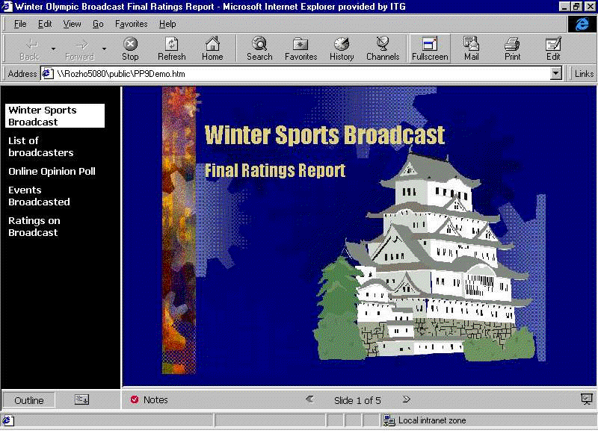
A Navigation Bar is automatically created for users when files are saved in HTML.

Notes Frames
A separate frame containing notes for each slide is also automatically generated if the author created notes in the notes pages.

Design Templates (Themes)
In addition to traditional templates, PowerPoint 2000 includes Design Templates using the same graphics elements as Themes in FrontPage and Word 2000. This allows users to create documents and Web pages with a consistent look across Office applications.

Present in Browser
Users can choose to view HTML presentations from the browser in the full screen mode with Internet Explorer 4.0 or higher. No additional viewer is needed for this.

Real-time Collaboration
Employees in organizations need to collaborate, to create documents and share their ideas and knowledge. One of the most efficient ways to accomplish this is through the Web. Today users of PowerPoint share their presentations as attachments in e-mail messages or by saving them out to file servers. Furthermore, Web servers are generally used as a one-way, read-only means of distributing information. Web servers are capable of providing two-way, real-time interaction, and PowerPoint 2000 helps enable a two-way Web.

PowerPoint 2000 integrates two Microsoft technologies, NetShow and NetMeeting, to enable to users to collaborate over the network in real time.

Presentation Broadcast
PowerPoint 2000 uses Microsoft NetShow technology to enable broadcasting of presentations to a wide audience over an intranet.

NetShow uses streaming multicast technology to distribute a live or recorded audio and/or video broadcast over an intranet. PowerPoint 2000 adds ease of use to the technology of NetShow to allow broadcasting presentations directly from within PowerPoint. A camera is not required but video is supported if users choose to include it. Since the presentation is sent in HTML, all the audience needs is a browser to view it on PCs, Macs or UNIX workstations. This could be used, for example, for company meetings, presentations to remote groups, or a team meeting at several different locations. No browser is needed for the presenter, but Internet Explorer 4.0 or higher is required for the audience. A NetShow server is required for audiences of 16 or more.

Presenters can schedule a presentation just like any other meeting using Outlook 2000. A Lobby Page is automatically generated and available when the audience is ready to tune in. When the presenter is ready to start the broadcast, the presentation is saved in HTML format and copied out to the specified server location. If a NetShow server is set up, the pages will be multicast automatically. As the audience tunes in to the Lobby page for the event, the HTML pages will be cached on members’ machines. When the presenter begins, a separate multicast stream with audio, video (if present) and the slide navigation commands will be sent to the audience. Viewers are also free to join in after the meeting has started.

Broadcast Schedule
A presenter can schedule a broadcast using the familiar meeting scheduling user interface in Outlook 2000. Invitations are sent to all participants when the meeting is scheduled. Meeting reminders pop up on the audience machines at the specified time. A button on the reminder takes the audience directly to the Lobby page.

Other options available when scheduling the broadcast include allowing the audience to have private chats and sending responses via e-mail to the presenter.
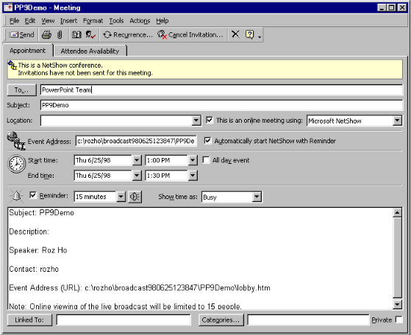
Users can easily schedule online meetings using Outlook 2000.

Event Web Page
This page is automatically generated when the presentation broadcast is scheduled. It provides a starting point when the audience is ready to tune in to watch a broadcast.

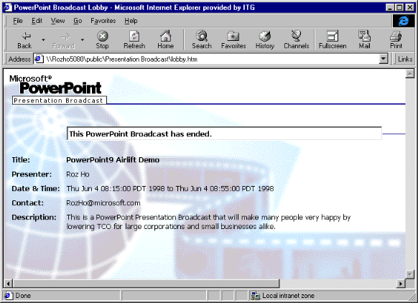
The Events page provides details about the online broadcast presentation.

Presentations on Demand
PowerPoint 2000 provides recording of the presentation as it is given live, which allows anyone who missed it to see and hear it later, just as the presenter gave it.

Online Meeting
PowerPoint 2000 enhances NetMeeting integration for presentations. This integration provides a consistent, standards-based real-time collaboration solution. As a result, PowerPoint 2000 provides an “Online Collaboration…Meet Now” command on the Tools menu, enabling users to automatically start NetMeeting in the background and share the current document with one or more people. This provides a simple way for PowerPoint 2000 users to collaborate with others. It automatically provides round-trip verification for commands that are communicated to remote users.

These meetings can also be scheduled ahead of time using Outlook 2000 and specifying the document to be shared. When the meeting reminder pops up, meeting attendees need only click “Join Meeting” in their calendar to see and edit the document. Everyone in the conference sees all changes to the document, and chat and whiteboard windows are also supported for easy communication outside of the document itself.

Outlook is not required to use this feature. Presenters can call participants using their corporate Internet Locator Server.

Personal Productivity
PowerPoint 2000 makes great strides in enhancing end-user productivity and conforming to user habits and preferences. Assistance is provided for the most common obstacles uncovered in usability tests and support calls. In certain instances these obstacles are automatically detected and fixed; at other times, advice is given to assist users in completing tasks efficiently.

AutoFit Text
In PowerPoint 2000, text is automatically resized to fit into a placeholder so that it doesn’t “fall off” the slide. AutoFit changes the line spacing, then the font size — and then both — to make the text fit. This means that users don’t have to spend time trying to make the text fit — it happens automatically.

Tri-Pane View
Microsoft has received feedback from customers that they want to be able to work more seamlessly with the various views in PowerPoint. In usability tests, we have also found that many novice users only work in slide view and never find the other views. PowerPoint 2000’s new Tri-Pane View allows users to combine their Slide, Outline and Notes views. Enabling one combined view of information makes it easy for users to perform tasks like adding new slides, editing text within a slide, entering notes while creating a presentation and navigating while editing.
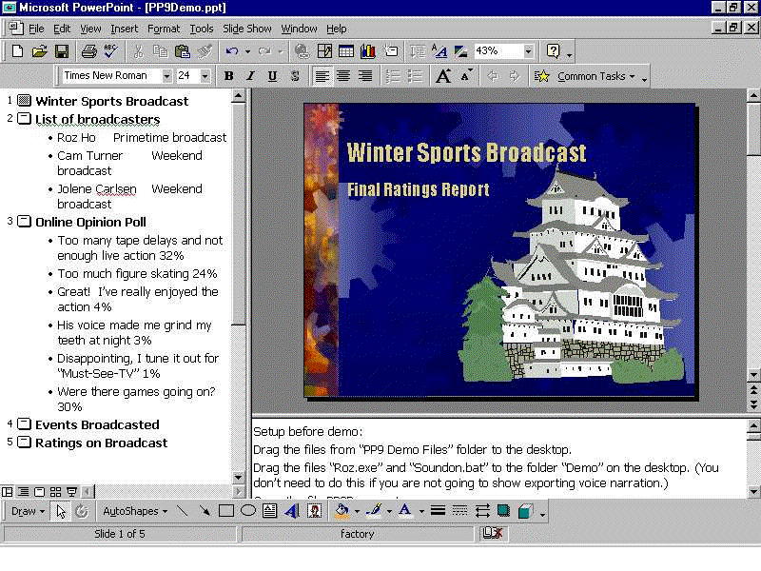
Tri-Pane View makes it easier for users to work with slides.

Tables
PowerPoint 2000 supports creation of tables without needing to use Word or Excel in place. These tables provide a subset of functionality supported in Word 2000 Tables. The PowerPoint team identified the most commonly used table features in Word and implemented them in PowerPoint. These features behave like those in Word and are composed of OfficeArt shapes to make them easy to edit. They are tied to text styles and themes, and visually round-trip to and from PowerPoint 97. If the tables are not ungrouped and edited in PowerPoint 97, they will continue to behave like tables when read back into PowerPoint 2000. If tables are ungrouped in PowerPoint 97, then they will behave like OfficeArt shapes when read back into PowerPoint 2000.

Graphical Bullets
PowerPoint 2000 supports the use of graphics in place of bullets. Several preset images are included, but any image can be used. Some PowerPoint 2000 Design Templates will include built-in graphical bullets. Additional graphical bullets are shipped in ClipArt Gallery. The user interface for graphical bullets is consistent with Word. Graphical bullets will be substituted by normal character bullets when displayed in PowerPoint 97.

AutoNumbered Bullets
One of the most requested features, AutoNumbered Bullets provides numbered bullets that automatically adjust their order in a logical sequence. These bullets recognize the user’s intent when entering a number, and format themselves as a numbered list. Only first-level paragraphs are supported by AutoNumbered Bullets.

AutoFormat as You Type
Besides numbered bullets, PowerPoint 2000 also recognizes ordinals, fractions, em-dashes and en-dashes, rich-text AutoCorrect entries such as ☺ and smart quotes followed by a number. This feature helps users complete their presentations faster by eliminating the need to constantly make corrections and adjustments manually.

Flexible Handouts
PowerPoint 2000 provides additional printing options of four or nine slides per page, giving users more ways to tailor the presentation to their specific style and preferences.

Multiple Monitor Support
PowerPoint 2000 allows a slide show to be dragged to a secondary monitor while the first monitor shows the edit view, allowing a presenter to preview the next slide, view the speaker’s notes, or even edit the slides before displaying them to the audience. This functionality requires Windows 98 or Windows NT 5.0, as well as hardware that supports dual video output.

Laptop Integration
Microsoft realizes that users frequently give presentations from their laptops. With PowerPoint 2000, Windows screensavers are disabled during a presentation. In addition, the laptop’s low-power screen mode has been disengaged to prevent interruptions during a presentation.

Slide-Show Usability
PowerPoint 2000 automatically hides the pointer and slide-show icon after a period of inactivity during normal full-screen slide show. In addition, minor mouse jiggles don’t cause the pointer to appear. This helps alleviate distractions during presentations.

Voice Narration
PowerPoint 2000 allows easy rerecording of the narration on a slide-by-slide basis, instead of forcing users to rerecord the entire presentation. Playback of narration is now synchronized with the original presentation, including all slide transitions and build animations.

Animated GIFs
PowerPoint 2000 supports displaying animated GIFs in slide show as well as on the Web. Once inserted into the presentation, animated GIFs can be moved and resized in edit view.

Additional AutoShapes
PowerPoint 2000 adds over 50 AutoShapes, including shapes for network diagrams, Web diagrams, conceptual diagram banners and office layouts. These are stored in ClipArt Gallery and accessed through the OfficeArt AutoShapes menu.

End-User Assistance and Training
Microsoft’s approach for providing assistance and training in PowerPoint 2000 is based on extensive customer research and usability testing. The PowerPoint team’s focus was twofold. First, build an assistance platform and user interface that helps users get the results they want, when they want and without interrupting the flow of their work. Second, engineer this assistance platform in such a way that it can be customized by IT administrators and extensible to the Web. Research findings guided the team in making improvements in many areas, including a more intuitive way to ask plain language questions, a more effective and less intrusive Office Assistant, and a powerful engine that monitors users’ actions and automatically presents the right help topic or tool.

Presentation Assistant
Using the Office Assistant, the Presentation Assistant in PowerPoint 2000 consolidates several features and adds some new ones to help users create great presentations. This is an integrated approach to assisting users throughout their efforts to create, publish and deliver presentations. Based on usability studies conducted over the past two years, we have identified several common obstacles for users and now provide further assistance through this feature. For example, a common obstacle is understanding the difference between objects on a slide and background objects on the master. If a user tries unsuccessfully to select master text or graphics on a slide, the Assistant will provide help on how to edit objects on the master.

PowerPoint Introduction
Becoming familiar with an application is important. PowerPoint Introduction is designed to help new users be effective using PowerPoint by providing a self-paced introduction that simply and easily explains essential PowerPoint 2000 concepts to new and infrequent users, helping them become effective users of the product more quickly. The introduction was created using PowerPoint tools, and a complete discussion of how it was made is included in the notes pages so users can understand how to make self-running interactive presentations.

Projector Wizard
Projectors are becoming more common in the corporate workplace, but they present usability problems for users. The most common obstacle is synchronization between the presenter’s laptop and the projector. The Projector Wizard automatically sets and restores correct screen resolution for the target projection system.

Animations User Interface
PowerPoint 2000 provides a more intuitive user interface than in previous versions for setting animations effects, order, timing and for previewing animations.

Multilingual User Support
Deploying PowerPoint 2000 across the world is much easier than doing so for previous versions because it uses a single worldwide executable in every version except the Thai, Vietnamese and Indian language versions. This means the same product can be rolled out everywhere and meet the needs of all users. This tremendously reduces complexity for administrators supporting PowerPoint in multiple languages and also improves multilingual support within documents for users.

Multilingual AutoCorrect
PowerPoint 2000 now supports one AutoCorrect list for each language, rather than one list shared for all languages, eliminating the problems that arose from a list for one language breaking correctly typed text in another language. For example, the English AutoCorrect list capitalizes all cases of the single letter “i,” but in Swedish this is a correct preposition. A user typing Swedish on an English system would previously have all of the “i’s” capitalized in error.

Support for Far East Users
PowerPoint 2000 also provides a number of improvements for Far East users, including additional Far East date formats for use in headers, footers and inline text; improved word breaking for Japanese and simplified and traditional Chinese; and support for Far East HTML tags.

Language AutoDetect
PowerPoint determines language based on keyboard settings and applies the correct proofing tools.

Conclusion
PowerPoint 2000 was specifically designed to offer improved Web-enabled information sharing, real-time collaboration, ease of use and international usage. As a part of the Office 2000 application suite, it also shares a number of other features that open the new realm of functionality enabled by Office 2000.

For more information: http://www.microsoft.com/office/


This is a preliminary document and may be changed substantially prior to final commercial release. This document is provided for informational purposes only and Microsoft makes no warranties, either express or implied, in this document. Information in this document is subject to change without notice. The entire risk of the use or the results of the use of this document remains with the user. The example companies, organizations, products, people and events depicted herein are fictitious. No association with any real company, organization, product, person or event is intended or should be inferred. Complying with all applicable copyright laws is the responsibility of the user. Without limiting the rights under copyright, no part of this document may be reproduced, stored in or introduced into a retrieval system, or transmitted in any form or by any means (electronic, mechanical, photocopying, recording, or otherwise), or for any purpose, without the express written permission of Microsoft Corporation.
Microsoft may have patents, patent applications, trademarks, copyrights, or other intellectual property rights covering subject matter in this document. Except as expressly provided in any written license agreement from Microsoft, the furnishing of this document does not give you any license to these patents, trademarks, copyrights, or other intellectual property.
Unpublished work. © 1998 Microsoft Corporation. All rights reserved.
Microsoft, FrontPage, NetMeeting, NetShow, the Office logo, Outlook, PowerPoint, Windows and Windows NT are either registered trademarks or trademarks of Microsoft Corporation in the U.S.A. and/or other countries.
The names of actual companies and products mentioned herein may be the trademarks of their respective owners.

